Using Netscape Messenger

1. Setting Up a User Profile

The Profile Setup Wizard leads you through the process of setting up Netscape Messenger and Collabra to work with your Internet service provider’s mail and news servers. The first time you run Communicator, after installation, you will be prompted by the Profile Setup Wizard. If you’re not prompted, it’s because Communicator has picked up your existing preferences from a previous installation of Netscape Communicator or an older version of Navigator.

Tip
You can create multiple profiles for Communicator. This is a handy feature if you have more than one e-mail account or if you share a computer with someone. To create a second profile, from the Windows98 Start menu, select Programs > Netscape Communicator > User Profile Manager. Then follow the steps outlined in this section, starting with step 2. If you do create additional profiles, every time you launch Communicator, a dialog box will appear and you can then specify which profile you would like to use for that particular session. Once Communicator is running, the only way to switch to another profile is by quitting and restarting the program.

If this is the first time you’ve run Communicator, you’ll need to follow these steps:
- Double-click on the Netscape Communicator icon on the Desktop to start up Communicator for the first time. A dialog box like the one shown in Figure 1 will appear. (This dialog box appears only the first time you run Communicator.)

Tip
You may want to change your preferences later. To do so, from the menu bar in Navigator, Messenger, Collabra, or Composer, select Edit > Preference. The Preferences dialog box will appear; in it, click on Mail & Groups, then you can change your preferences

Figure 1
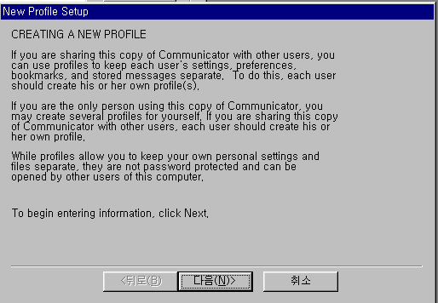

- Click on the Next button to continue. A dialog box will appear; in it, you need to enter your name-this is your normal, everyday name-and your e-mail address. (See Figure 2.)

Figure 2
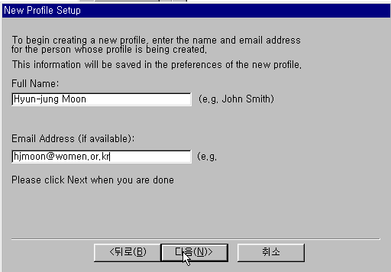

- Click on the Next button to continue. A dialog box will appear; in it, your profile name and the location of the directory in which your profile is stored will both appear. (See Figure 3.) Unless you have good reason, don’t make any changes to this stuff.

Figure 3
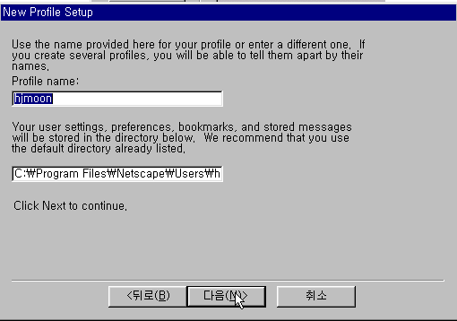

- Click on the Next button to continue. The Contents of the New Profile Setup dialog box will change-see Figure 4. In the dialog box, enter your name, your e-mail address, and the name of your outgoing mail server. (women.or.kr only in this train.)

- Click on the Next button to continue. The contents of the dialog box will again change. (See Figure 5.) In the incoming Mail Server text box enter the name of the mail server from which you get your e-mail (women.or.kr). Finally, select the radio button that corresponds to the type of server that it is: POP3 or IMAP. Odds are that your ISP has a POP3 server, so select POP3 unless your ISP has instructed you otherwise.

Figure 4
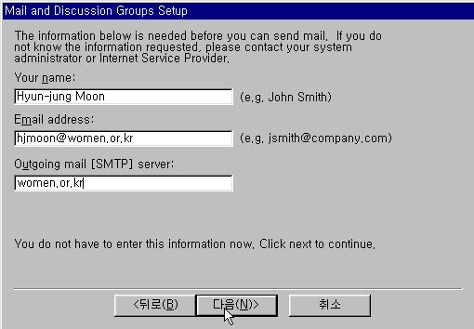

Figure 5
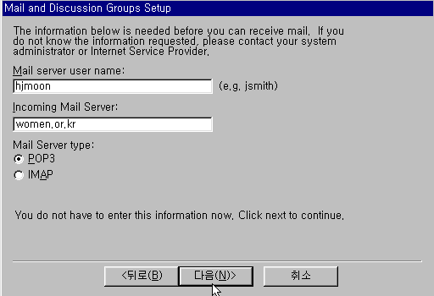

- Click on the Next button. The final dialog box (see Figure 6) in this procedure asks for your part number and the name of your news (discussion group) server. Enter the name of the news or discussion server you use. (See Table 1 for the names used by some popular ISPs and online services; if you use a provider that’s not on this list, ask them for this info.) Unless you’ve been instructed differently, leave the port set 119. This is the default port number for news.

Figure 6

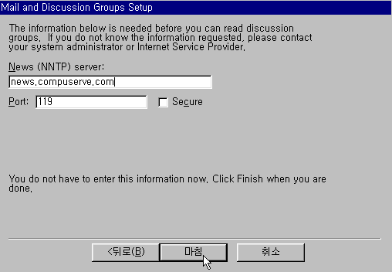

- Click on the Finish button. The Netscape License Agreement dialog box will appear.

- Read the agreement and, if you agree with its terms, click on the Accept button. The Netscape Navigator window will appear.

Table 1

Connection | Outgoing Mail (SMTP) Server | Incoming Mail  (POP) Server | New(NNTP) Server
CompuServe WinCIM | mail.compuserve.com | mail.compuserve.com | mail.compuserve.com
Netcomplete or NetCruiser | smtp.ix.netcom.com | popd.ix.netcom.com | nntp.ix.netcom.com
Microsoft Network | mail.msn.com | mail.msn.com | news.msn.com

2. Sending and Receiving E-mail

2.1 Starting Messenger
You can start Netscape Messenger a number of ways:
- From the Navigator menu bar, select Communicator > Messenger Mailbox. The Inbox window will appear
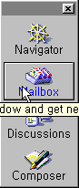
- In the Component Bar, click on the Mailbox icon:

The first time you check your e-mail, the Password Entry dialog box will appear.

In the text box in the Password Entry dialog box, enter the password assigned to you by your internet service provider (or intranet administrator), and click on OK. In a few seconds, the Message List window will appear. You can see a Message List window in Figure 7.

The Total, Unread, and Message column headers at the far right of the message window can be difficult to see; in order to display them, you may have to resize the Message List window, or click on the arrow button on the far right of the window.

You can also click on the name of a message column and drag it anywhere else in the Message window to reorder the column header buttons. In addition, you can make the column headers wider or narrower by clicking on the dividers between the columns and dragging them to the left or right.

The text of a selected e-mail message is not displayed in the Message List window by default; to read a message, either double-click on its message header to open a new Message window, or click on the Show Message icon to display the message text within the Message List window.

Figure 7
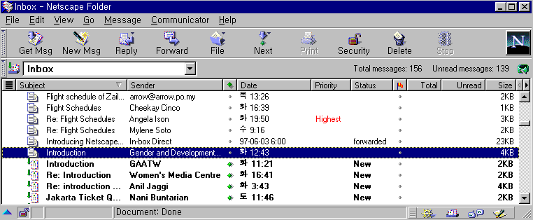
Click here to expand columns
Click here to collapse columns
Total unread message in thread
Column Headers or Message headers
Show Message icon

2.2 Creating Messenger

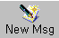
If you’re already connected to the Internet and just want to dash off e-mail or two, you can click on the New Msg button wherever you happen to be:

The Message Composition window will appear.
- If you’re in the Navigator browser window, use the menu bar to select File > New > Message.
or
If you’re in the Message window, click on the New Message button. In either case, the Message Composition window will appear (See Figure 8.).

- In the To text box, next to the icon of a human being, type the e-mail address of the person to whom you want to send an e-mail message.

- Click in the Subject field and then type a subject for the message you are about to write. Remember, the more descriptive or informative the subject link is, the more useful it will be to the recipient of your message.

- Next, click in the big box at the bottom of the window (called the body of the message), and start typing your message.

- When you’re done typing your e-mail message and are ready to send it, click on the Send button at the top of the window. Your message will be on its way in a matter of seconds. The messenger window you were in previously will reappear.

Figure 8
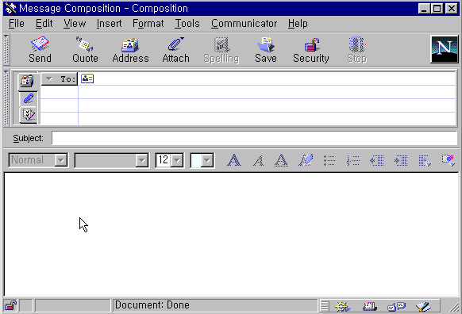

Tip
Because online time is precious (and costly), you don’t have to be connected to the Net to compose an e-mail message. You can open up Messenger when you are “offline’ (not connected to the Net) and compose a message to be sent later. You can also save a draft of a message if you want to finish composing it later.

2.3 Making Courtesy Copies and Blind Courtesy Copies

Messenger lets you send courtesy copies (“Cc”) and blind courtesy copies (“Bcc”), which are commonly added to office memoranda. A courtesy copy is a copy of a message or document sent to an interested party other than the person for whom the original is directly intended. A blind courtesy copy is sent without notifying the primary recipient that other folks are getting a copy of the message. To specify courtesy copy recipients, follow these steps:
- Click on the New Msg toolbar button. The message Composition window will appear.

- In the To address line, enter the e-mail address for the primary recipient of the message.

- Press Enter and a new address line will be added, beginning with “To.”

- Click on the word To: next to the address you just typed and hold down your mouse button. A drop-down list of menu items will appear. Select “Cc” for people to whom you want to send copies, or “Bcc” for courtesy copies that you don’t want the other recipients to know about.

- In the new Cc or Bcc field you just created, type the e-mail address of the courtesy copy recipient.

- If you want to add another “Cc” or “Bcc” recipient to your message, press Enter to create a new address line, and follow steps 4 and 5 again. If not, continue to compose a subject line or text for your message.

Once you’ve made sure that copies of your message are going to all the people you want to receive it, you can type your message and send it on its way.

2.4 Attaching Files with Messenger

Messenger gives you a couple of options for attaching file to an e-mail message. Both ways are accessed while the Message Composition window is active. With the Message Composition window open, follow these steps:
- Click on the Attachments tab (the one marked with a paper clip) that is located to the left of the Address section of the Message Composition window. Clicking on it opens the Attachment area of the Message Composition window.

- Click on the blank white attachment area and the Enter File to Attach dialog box will appear
or
From the Message Composition window, click on the Attach button, and choose File. The Enter File to Attach dialog box will appear.

- Locate the file you want to attach by navigating through the folders on your computer. Click on Open; the Enter File to Attach dialog box will close, and you’ll return to Message Composition window. The name of the file you just selected is now added to the attachment area.

- When you’re finished composing your message, click on the Send button; the status message area at the bottom of the Message Composition window will notify you of the progress of sending the attachment. When the message is sent, attachment that has been attached to the message being composed.

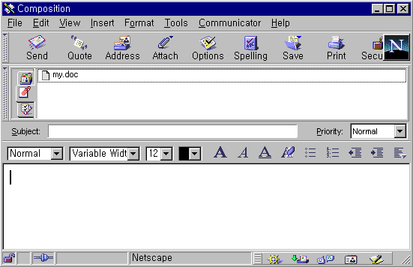
Attach button #1
Attach button #1

You can send more than one attachment to your message, but be sure the combined file size don’t get too large, or the transmission might take quite a while. After you have attached your information, click on Send, and your message and its attachment(s) will be sent.

2.5 Reading Your Mail

To read your e-mail messages, follow these steps:
- If you have the Navigator browser windows open, select Messenger Mailbox from the Communicator menu. The Inbox message window will open, and your list of e-mail messages will be displayed.

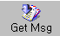
- Once you have one of the Messenger windows open, in order to get any new messages that you haven’t read yet, you’ll need to click on the Get Msg toolbar button. If you’re connected to the Internet, Messenger will display a dialog box telling you that the mail server is being contacted, and informing you how many messages are being downloaded.

- If you don’t have any new or unread messages on your mail server, a dialog box will tell you that, too. Click on OK in that dialog box, and you’ll return to the Message List window you were in previously.

- When your new e-mail messages arrive they’ll be added to your currently displayed Message list. New messages aren’t difficult to spot: They’re displayed with bold type and have the word “new” in the Status column. Mew messages also have a green arrow and a closed envelope icon to the left of the subject line.

- You can read a message in its own Message window, or you can read the message in the bottom of the Message List window. To open a new Message window, double-click on the message subject line in the Message list. A new window will open containing the message.
or,

Alternatively, you can click on the blue triangle in the bottom-left corner of the Message List window to display the message content area. If you click on a message, it will be displayed in the Message List window.
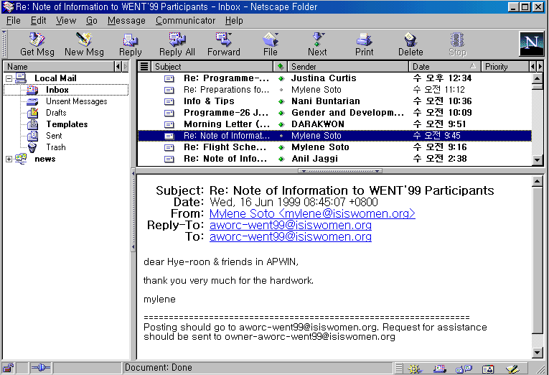

2.6 Reading an Attachment

In order to download the attachment, follow these steps:
- Scroll to the bottom of the e-mail message. Messenger displays a table that tells you what kind of file has been attached.

- Click on the underlined hyperlink within this rectangle to download the attachment. Messenger will display a Warning dialog box that tells you about potential security problems (such as viruses) that you may encounter when downloading an attached file.

- Click on the button next to the words Open it in the Warning dialog box if you have the application needed to open the attached file.
or,
Click on save it to Disk if you want to save the file to disk, and use the Save as dialog box as you would normally.
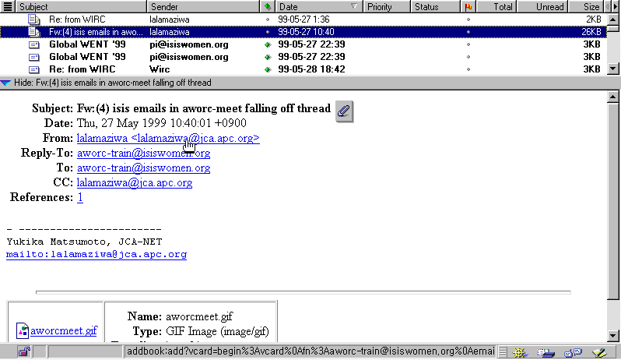
Paper clip icon
Click here to download attached file

2.7 Replying to a Message

Replying to a message is very much like wirting a new message. Just follow these steps
- With the message to which you want to reply on screen, click on either the Reply or the Reply All button. The Message Composition window will appear.

- In the Message Composition window, you’ll see that the Mail To, and Subject files are already filled in, based on information that came from the message to which you are replying. You can modify and of these fields if you like, or you can leave them “as is.”

- In the text area near the bottom of the window, type your message. You can include the contents of the original message in your reply by clicking on the Quote button.

- After you type your e-mail message, click on the Send button.

2.8 Forwarding an E-Mail Message

If you receive an e-mail message that you just can’t wait to show a third party, Messenger lets you forward it quickly by following these steps:
- With either the Message window or a Message List window open, click on the Forward toolbar button, select Message > Forward. The Message Composition window will appear with the title of the message you want to forward visible in the Subject line.

- In the To: field, enter the e-mail address of the person(s) you want to receive the forwarded message

- The contents of the message that you want to forward don’t actually show up in the Message Composition window. In fact, the area of Message Composition that normally contains your e-mail message appears blank when you forward someone else’s message.

- Click on the Send button. (If you are offline and want to send the message later, select Message > Send Later.) When the message has been sent, the Message Composition window will close and you will return to the Message or Message List window you were in earlier.

