Using Netscape Navigator

1. Installing Netscape Communicator

Warning
Before you start the install process, close any files you have open so that you don’t have to stop in the middle of the installation procedure and go back to see if you have left any files open.

- Double click on the Setup.exe or c32e40.exe (see Figure 1). A status bar will appear in the dialog box to show the progress of files being extracted (see Figure 2). After this is done, a setup screen will open on your Desktop, as shown in Figure 3.

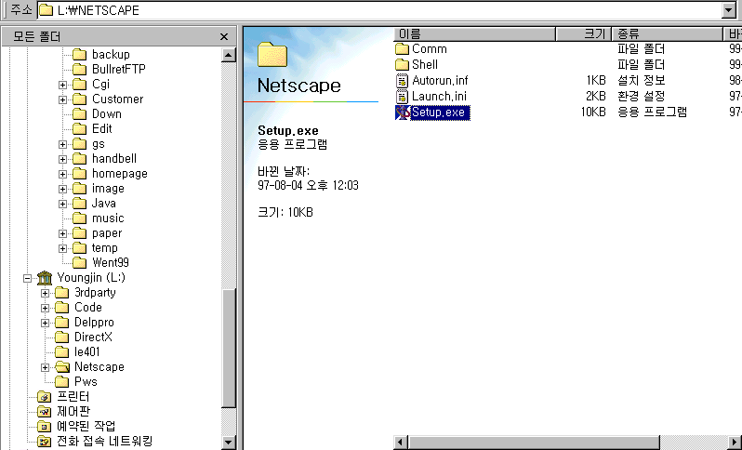
Figure 1

Figure 2

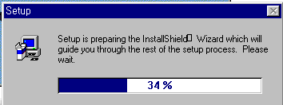

Figure 3
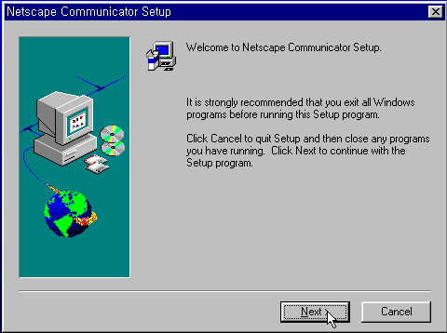

- Click on the Next Button to continue the installation. The Software License Agreement dialog box will apear (Figure 4).

- Read the software license agreement, and, if you agree with it, click on Yes. (If you don’t agree to it, click on No and you’ll be returned to the Windows Desktop). The Setup Type dialog box will appear (Figure 5).

Figure 4
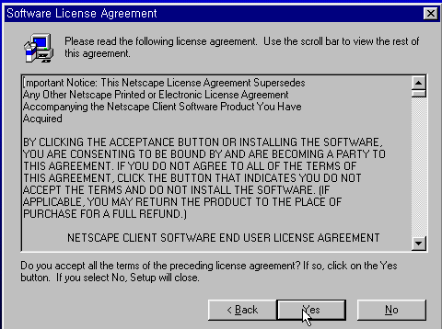

Figure 5
.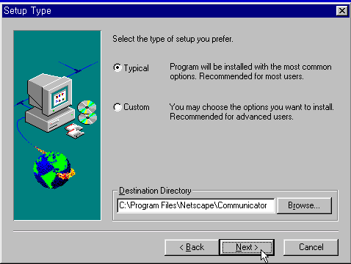

- In the Setup Type dialog box you can choose whether you want to install all of Communicator’s components, or just selected components.

- You can also select the target directory into which files will be installed.

- Click on the Next button to continue. The Select Program Folder dialog box will appear (Figure 6).

- In the Select Program Folder dialog box, you can specify the name of the folder in which Communicator’s icons will appear. Click on the Next button to continue. The Start Copying Files dialog box will appear (Figure 7).

- The Start Copying Files dialog box represents your final chance to make changes to your selections before installation begins in earnest. If you have misgivings about anything you’ve chosen or specified, click on Back and return to earlier steps, where you can change your choices. If you are happy with what you’ve selected, click on Install. A dialog box will appear; its purpose is to keep you informed of progress as Communicator is installed.

- At this point, installation is pretty automatic. Once it’s complete, a dialog box will appear asking if you would like to read Communicator’s README file (Figure 8). This file contains additional information about Netscape Communicator and it’s a good idea to take a look at it. Click on the Yes button to view the README file. When you’ve finished, from the menu bar, select File  Exit. The Windows Desktop will reappear and the Restarting Windows dialog box will be visibel.

Figure 6
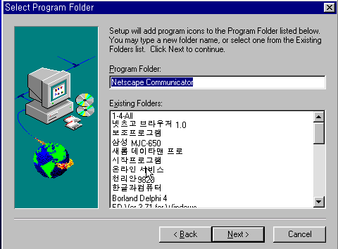

Figure 7
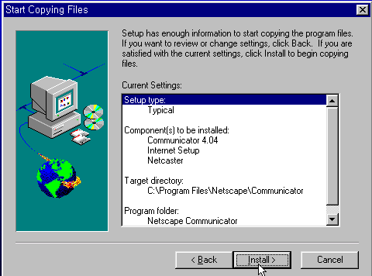

Figure 8
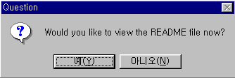

- To complete installation of Communicator, you’ll have to restart Windows. In the Restarting Windows dialog box, select the radio button labeled Yes, I want to restart my computer now, then click on the OK button. Windows will restart.

Once Windows restarts, you’re done. Communicator is installed neatly on your computer, and on your Desktop you’ll fild a window containing icons for each of the Communicator components (Figure 9).

Figure 9
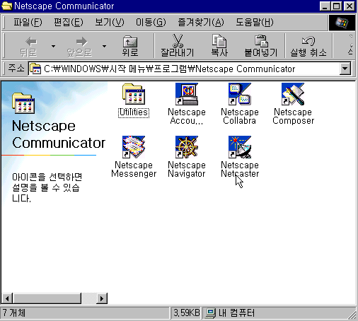
2. Customizing Nestcape Communicator

To change most of the things that can be changed in Communicator, you’ll start from the Preferences dialog boxes. To open it up and get started, follow these steps:
- With Netscape Communicator running, from the menu bar, select Edit > Preferences. The Preferences dialog box will appear.

- Along the left side of the Preferences dialog box, you’ll see a list of categories. Click on the category of interest. The contents of the dialog box will change to reflect your choice.

  - Choosing which Component will Start Up First

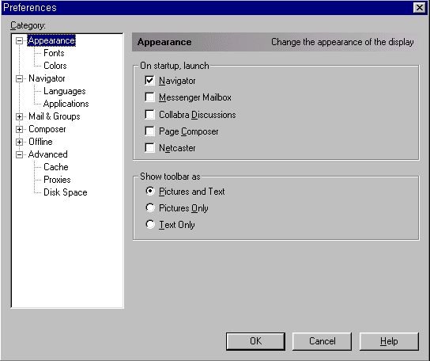

2.2 Altering the Size of Buttons on the Toolbar

You can have it your way, with the toolbar showing Pictures and Text,
Picture Only,
or Text Only (bottom).

2.3 Changing the Size of Text

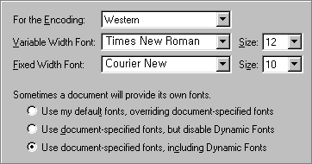

Specifying Colors & Selecting the Look of Links

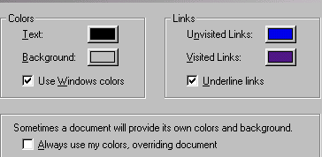

You can choose whether you want the selections you are about to make to override the design settings in any documents or messages you’ll be viewing. For example, you might want all text other than links in all the documents you ever view to be purple, even if the document’s designer made the text black. Or you might want the document designer’s wishes to outweigh your own. To make your own color choices override any other settings, select the check box labeled Always use my colors, overriding document.
or
To allow the settings that exist in a given document to override the color choices you are about to make, deselect the check box labeled Always use my colors, overriding document.

Changing Your Start-up Home Page

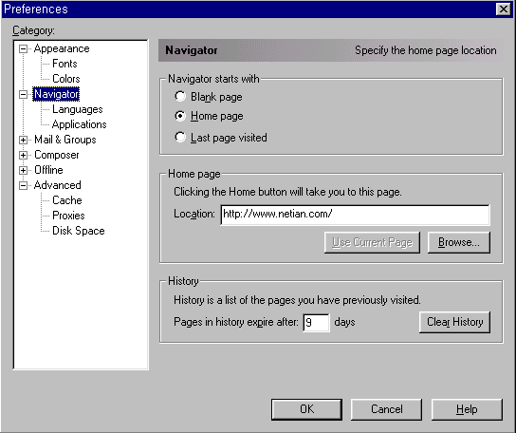

Selecting a Language

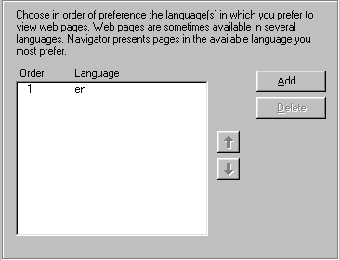

When you load a Web page, Communicator sends a list of preferred languages along with the request fot the page. (If you don’t specify some other preferred language, English will be assumed.) Some very sophisticated Web servers can use that information to determine which version of a Web page that exists in multiple languages to send back to Communicator. For example, a Web developer might create multiple versions of a page showing different pricing for merchandise depending on which country (as determined by language) a user has specified.

To add specify preferred languages, click on the Add button. The Add Language dialog box will appear.

Languages in this list will be arranged from the highest priority to the lowest. You can set these priorities. To change the priority of languages in the list, highlight the language you want to move up or down in the list. Click on the up or down arrow to your intention. The position of the selected language will change every time you click on one of these buttons.

  - Changing Your name, Email address, and Reply-to address

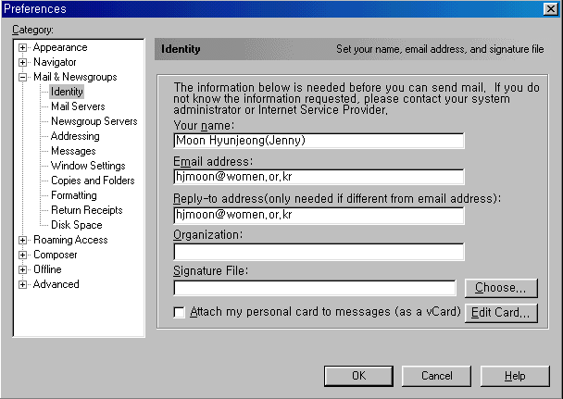

Changing Mail Server

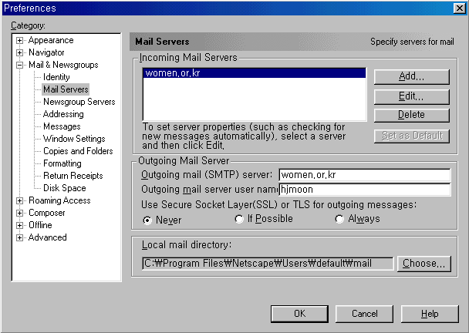

To Add a new Imcoming Mail Server, click on the New button.

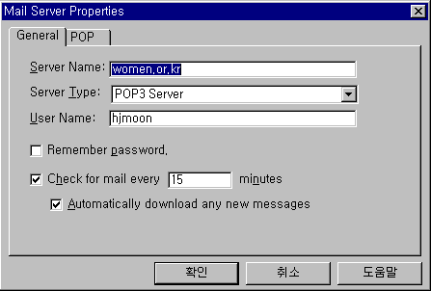
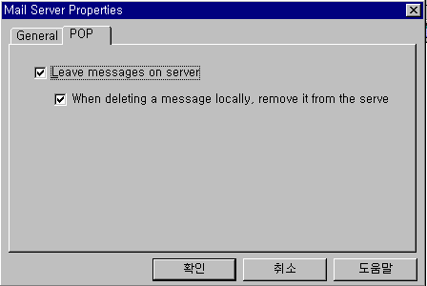

  - Changing the automatic loading of page components

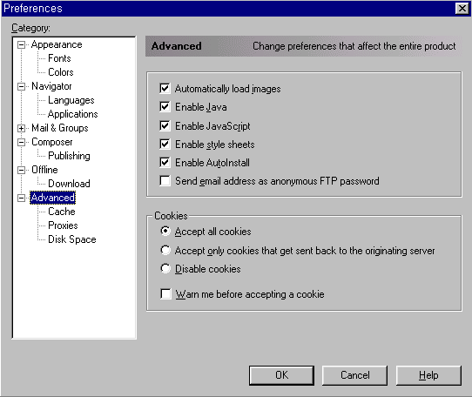

Option | What Selecting It Does | What Deselecting It Does
Automatically load images | Makes images appear automatically | Stops images from appearing, though you can override this “on the fly” for individual pages
Enable Java | Allows Java applets embedded in a page to run automatically | Disallows the running of Java applets
Enable JavaScript | Allows JavaScrpit embedded in a page to run | Disallows the running of JavaScript
Enable Style Sheets | Forces Web pages to be displayed in accordance with any associated style sheets | Disallows the application of style sheet information for a given page
Enable AutoInstall | Enables the automatic downloading and installation of plug-ins when they are needed | Disallows automatic downloading and installation of plug-ins
Send Email Address as Anonymous FTP password | Sends e-mail address as password for anonymous FTP sessions | Send a dummy password for anonymous FTP sessoins, in which case some FTP sites proceed with the session

Option | What Selecting It Does
Accept All Cookies | Allows all requests to set cookies to be accepted
Accept Only Cookies that Get Sent Back to the Originating Server | Allows only a site you are currently visiting to set a cookie
Disable Cookies | Disallows all requests to set cookies

Specifying How Often to Check the Cache

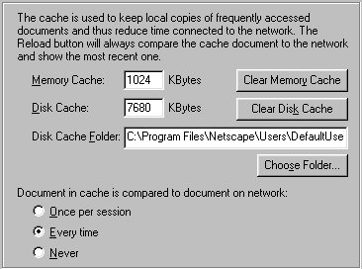

Communicator stores the pages you visit in what’s called the cache. Communicator caches the Web pages you look at so that when you go back and forth between pages, you don’t have to access the Internet anew every single time you look at the same page. Instead, your machine accesses the copy of that page in the cache.

Option | What It Means | When It’s Good
Once per Session | Navigator will go looking for each page once (the first time you access this particular Web page in this particular session). | During your usual activities.  This is the default, and it’s best to call this a keeper.
Every Time | Navigator will not look at your disk cache and will always retrieve from the Internet (instead of locally). | When you’re viewing lots of pages that change frequently, and especially if you’re on a high-speed line.
Never | Navigator will always go for the copy in your disk cache unless it becomes unavailable (or unless you click on the Reload button). | When you’re not connected th the Net and you want to look at pages in the cache.

Specifying a Proxy Server

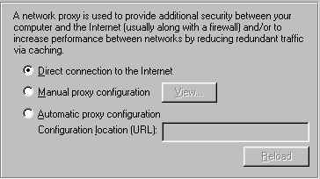

If you’re running Communicator on a corporate network that includes a firewall or proxy server, you’ll have to make some changes to Communicator to get ir working. Basically, you’ll have to provide information about the firewall so Communicator can properly access the Internet.

If you have a direct connection to the Internet, you do not use a proxy server.

Some proxy servers support a feature called Automatic Proxy Configuration. If this option is avialable to you, you can simply provide a URL that points to information about the proxy servers on your network.

Finally, if your network users a proxy server without automatic configuration, Select the radio button labeled Manual Proxy Configuration. Click on the View button. The Manual Proxy Configuration dialog box will appear. The network administrator can help you determine which of these servers your company runs and whar the proper IP addresses and port numbers for each fo them are.

