Virus Awareness

A computer virus is an irregular, human-made program designed to infect computers.

There are two types of virus:

Conventional virus

A conventional virus infects the floppy disk or hard disk of a computer. It is found either is the System area or in Program Files. It will usually have the file extension .exe, which means it is an executable program. A virus in the form of an executable file will only begin to cause problems when it is executed (i.e., when you run or open it).

Macro virus

A Macro virus infects the data file created by software such as Microsoft Word and Microsoft Excel. This is a newer type of virus, and its incidence is increasing. A Macro virus will only begin to cause problems when the file containing that Macro is opened.

How you can be infected
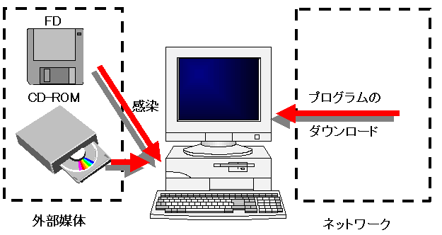
[graphics from: http://www.qr.cas.uec.ac.jp/~masasi/nyumon.html]

Every time you use external media, you risk receiving a virus. When you use the Internet, you are more exposed to the possibility of receiving a virus unknowingly.

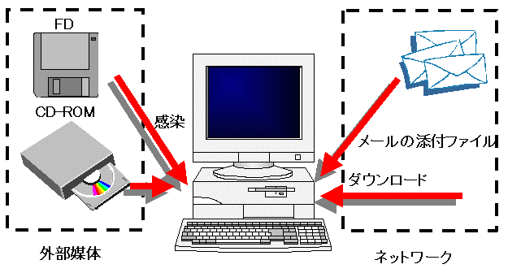[graphics from: http://www.qr.cas.uec.ac.jp/~masasi/nyumon.html]

Symptoms
The symptoms of virus infection will vary depending on the virus. These may include:
- Screen display problems
- Computer doesn't boot, or takes a long time to boot
- System hangs up
- Unusually frequent disk activity
- Files deleted or destroyed
- Hard disk corruption

It should be noted, however, that these problems are not necessarily the result of virus infection. They may be a hardware or software error.

Checklist: Protecting your computer from viruses
- Ensure you have installed the most recent Anti-Virus software. Check the vendor's Web site regularly for updates.
- Always back up your data. If a virus infects your computer, you may need to rebuild your data from these backups.
- If you believe you have been exposed to a virus, and notice any of the above symptoms, run your Anti-Virus software immediately.
- Always scan your email attachments with Anti-Virus software before opening them. Pay particular attention to Executable files (i.e., files with a .exe file extension), Microsoft Word and Microsoft Excel files.
- When you open a Microsoft Word or Microsoft Excel file that contains Macros, you will be asked 'Do you want to disable Macros?' In most instances, you should select 'Yes'.
- If you share a computer, have an agreed protocol with other users that covers caution when using external media, and regular Anti-Virus scanning.
- Only download software from Web sites you trust. Even then, it is wise to check for viruses.

Checklist: What to do if you are infected
- If you don’t know very much about the computers or virus, seek help from someone knowledgeable in these areas. It is good to be part of a local support group (such as AWORC), where people can provide advice or assistance if the situation should arise.
- If you are familiar with the Vaccination function of Anti-Virus software, kill the virus and check all external disks so infection will not happen again.
- If you share a computer or are connected to a local area network, notify other users about the virus in order to raise awareness and take preventative action.

