Exercise: Using the Web

Task 1 Teaching on the WWW 1

Task 2 The Whole Frog Project 2

Task 3 The Visible Human Project 3

Task 4 Web Multimedia 5

Task 5 Web Animation 6

Task 6 Plug-ins 8

Objectives
After the exercises, participants should be able to:
- Have an awareness of the many possible uses of the Web.
- Have an awareness of the Web as a dynamic media.
- Have familiarity with the use of plug-ins

*Some of the materials used here were inspired by the Netskills Training Course.

Task 1 The Children’s Virtual Hospital

Activity 1.1 Access the Virtual Children’s Hospital Information for Healthcare Providers page:
http://www.vh.org/VCH/Providers/Information.html
Note It is important to copy the URL precisely, as it is case sensitive. Get in the habit of using the bookmark facility in your browser, so that you can easily return to a page without having to re-type its URL.
This page contains links to numerous resources, using several classification schemes.
Figure 1. Virtual Children’s Hospital Healthcare Providers Index Page
Activity 1.2 From the section Information by Type select the link Multimedia Textbooks. From the following page select a topic and try to get an overview of the resources which have been made available. The Multimedia Textbooks and Multimedia Teaching Files include tutorials on a number of subjects.

Task 2 The Whole Frog Project

Activity 2.1 Access the Whole Frog project at:
http://george.lbl.gov/ITG.hm.pg.docs/Whole.Frog/
Whole.Frog.html
Click on the link Forms-based virtual frog dissection which will take you to the Virtual Frog Dissection Kit.

Click on the frog at the top of the page, as this is the link which takes you to the frog to be dissected. Figure 1-2 shows a virtually dissected frog using the kit.
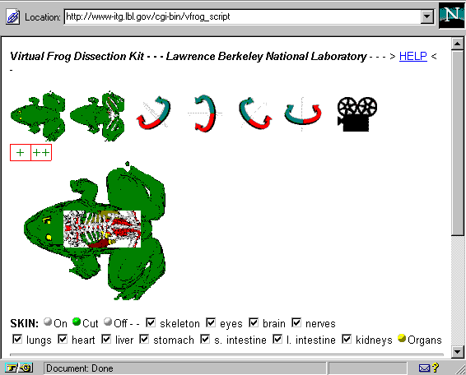
Figure 2. A Virtually Dissected Frog
Read the instructions on this page about how to dissect the frog. Experiment with the dissection kit trying different combinations of the variables available to you.
Activity 2.2 The Whole Frog Project also provides short movies, rotating the dissected frog to show its anatomy. Return to the Whole Frog Project home page at:
http://george.lbl.gov/ITG.hm.pg.docs/Whole.Frog/
Whole.Frog.html
Select the link:
Rotating, Transparent Frog Movie
On this page there is a link to:
MPEG movie of frog rotating (769kbytes)
Note If Netscape Communicator asks what you want to do with the file click the “Open it” option.

Task 3 The Visible Human Project

Activity 3.1 Open the NLM home page (shown in Figure 3-1) using the URL:
http://www.nlm.nih.gov/research/visible/visible_human.html
Read the overview of the project. Scroll down the page to the Further Information section and select the link images and animations. This page offers a number of photographs and scans which you can look at.
Figure 3-1. The Visible Human Project
Activity 3.2 Select the link Color photographs of cryosections and scroll down the page to see the images. Figure 3-3 shows an example of some of these images. If you want to see a larger version of an image, click on the small image and a larger version will be loaded.

Activity 3.3 Go back to the Images and Animations page by using the back button.
Note If the browser you are using has the appropriate Helper Application (an MPEG viewer) to assist the browser to handle this file, then you can select the link animated trip through the Visible Human male cryosections. This is a large file and may take some time to load.
Activity 3.4 Go back to the Visible Human home page at
http://www.nlm.nih.gov/research/visible/visible_human.html
The page should look something like Figure 3.2.
Scroll down to the section entitled Projects Based Upon Visible Human Data, and select the link NPAC Visible Human Viewer. This will allow you to select and view high-resolution images of 2-dimensional slices of a human body.
Note In case of server problem, go to mirror site:
http://www.dhpc.adelaide.edu.au/projects/vishuman/VisibleHuman.html
Figure 3-2. Visible Human Project mirror site.

Task 4 Web Multimedia

Activity 4.1 You will access Victoria Museum’s Ed-Online Site. Enter the URL:
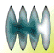http://www.mov.vic.gov.au/ed-online/
and click Global Classrooms (which changes color when you mouse over it)
Activity 4.2 Read the contents of the page. Click Oral Histories.
Figure 4-2. Global Classroom’s top page
Activity 4.3 Once in the Oral Histories page, click Hear Her Voice.
Note: “Hear Her Voice are the stories of women in the migration process. It looks at their dreams, aspirations, family ties, disappointments and achievements, while capturing some of the diverultural background, patterns immigration and experiences of settling.” (about Hear Her Voice)

Activity 4.3 On Hear Her Voice page, click the only woman’s name that is underligned. Listen to Leopoldine Mimovich.
Note: In case the multimedia page won’t play, click the the button that says restart .”

Task 5 Web Animation

Activity 4.1 You will access Ultralights Web site. Enter the URL:
http://goultralightsgo.com/spring/movies.html
Activity 4.2 Move your mouse over the page, and watch what happens. Select, and click the small square that “says” NUNO on the page. Wait until the whole page downloads.

Activity 4.3 Move your mouse over the page, and watch what happens.

Task 6 Using Plug-ins

Activity 5.1 In your browser, go to the Help menu and select About Plug-ins. This will tell you about all the plug-ins you have installed in your browser. Scroll down and see if you recognise any of the plug-in names, such as Shockwave, QuickTime.
Each plug-in allows you to view a specific file format, or set of formats, for instance the QuickTime plug-in allows you to view QuickTime movies with the extension .mov
Scroll back to the top of the page and select the link click here for more information about plug-ins. This site at Netscape allows you to download other plug-ins.
Activity 5.2 Go to the Adbsuters Home Page. Type URL:
http://adbusters.org/main/
Select Uncommercials . Listed on the page are links to TV “uncommercials” produced by The Media Watchdog over the years.
Click on the links to Obsession Fetish . Read the information about the featured “uncommercial.” Scroll down towards the bottom, and click on view the Movie in Quicktime. Wait until the movie downloads. Then click the triangle on the left of the Quicktime screen that points to the right.

