Exercise: Using Search Engines

Task 1 Using a Search Engine 1

Task 2 The One World Information Portal 2

Task 3 Searching a Subject Index 3

Objectives
When you have completed these exercises you should be able to:
- Use AltaVista for simple searching
- Have some familiarity with specialized search and directory services

Task 1 Using a Search Engine

Activity 1.1 In your WWW browser enter the URL:
http://www.altavista.digital.com/
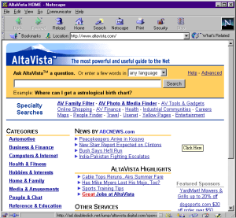

Figure 1 The AltaVista Page
Activity 1.2 Search for women right Asia by typing the words into the text entry box and clicking the Search button. When finished with the first page of search results, scroll towards the bottom of the page to look for more pages of results. Click on one of the numbered links to view other pages or "screenfuls" of results, as shown at Figure 2:
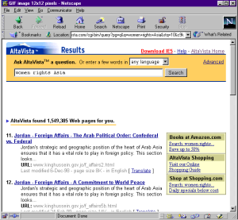

Figure 2 Selecting Another Page of Search Results

Task 2 The One World Portal

Activity 2.1 In your WWW browser enter the URL:
http://www.oneworld.org/
Note The One World Information portal is interesting for several reasons:
It offers the option of choosing to search either One World’s database or those of its member organizations—human rights, social justice and development organizations.

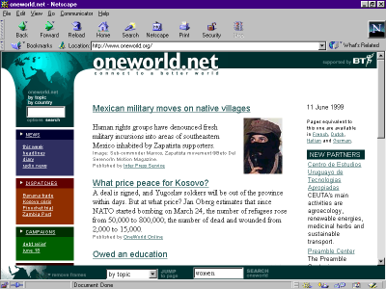As well as browsing, this type of portal generally offers you the chance to search by entering a search term in a box. In One World, resources have also been indexed by topic, and by country.
Figure 3. The One World Home Page
Activity 2.2 On the buttom of the One World Home Page, enter the search term women’s right. Click on Search One World. The Return page looks something like Figure 4.
The return page will have a listing of resources. Notice the descriptive abstract, the size of the file, the source URL, date of publication or modification, rank and score; this is designed to help you make a decision before going to the source site.
You are also given two display options: Compact, Normal and Clustered. The default display is Normal. Click Compact and examine the difference. Do the same with the Clustered option.
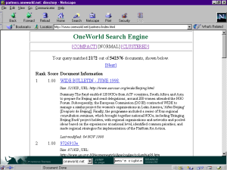From the results page you can select the title you wish to read and this should take you to the page that is described. Take some time now to explore any links that sound of interest to you.
Figure 4. One World Search Return Page

Task 3 Searching a Subject Index

Activity 2.1 In your WWW browser enter the URL:
http://www.oneworld.org/
Activity 2.2 At the buttom of the One World Home Page, click pull down menu and choose by topic. Click Jump to Page.

Figure 6. One World’s Search menu

Activity 2.3 One World will gice you a listing of all their subject indeces. Chose one subject and click. You will then be returned a list of resources about the subject you chose. Notice that if you select one of the links (or scroll down the page) you can find a short description of the resource, the original source, date published, and some cross indeces. If you click on the title of the resource, you will be returned the full text of the resource or article. Explore some of the resources that are of interest to you.

