Uploading your page using WS_FTP

This tutorial will guide you step by step through configuring WS_FTP to exchange files between your computer and your Xoom web site.

Step 1 - Download WS_FTP

If you haven't already done so, please download WS_FTPLE and install it on your computer. You can download WS_FTP from the Tucows (http://www.tucows.com).

This is a compressed file, so you will need a decompression utility to unzip this file. If you do not h ave one, please visit the Tucows (http://www.tucows.com) and download one now.

Step 2 - Open WS_FTPLe and create a Session Profile.
Once you open WS_FTPLE, the first screen you will see is the Session Profile screen, which will look similar to this:
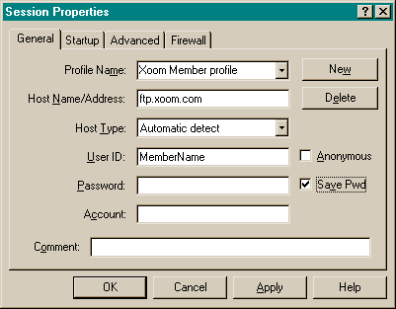
1. You'll need to enter the following settings in your Session Profile:
- Profile Name: Went99 web Site (you get your choice on this one)
- Host Name: women.or.kr
- Host Type: Automatic detect (default)
- User ID: Insert your ID (such as went01) here.
- Password: Insert your password here

2. If you wish, you may choose to save your password so that you don't have to enter it each time you log in with WS_FTPLE. If you wish to enable this time saving feature, check the box marked “Save Pwd” like this:

3. Be sure the Anonymous box is unchecked. Do NOT enter any other information beyond this. There is no need to enter a directory name; the above settings will automatically place you in your base directory.

When you are finished entering these settings, click on the OK button, and you will be connected to your Xoom server.

Step 3 - Transferring Files Back and Forth
Now that you are logged into your Xoom web site, the WS_FTPLE screen should look similar to this:
in your computer
Internet

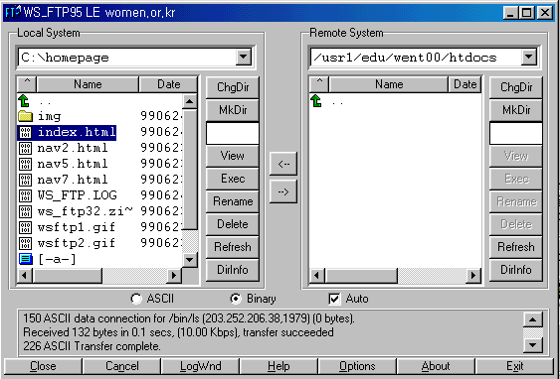

As shown above, the left hand window displays the directories and files on your local hard drive, and the right hand window displays the directories and files on your Xoom web site. To transfer files from one window to the other, simply click once on the file you wish to transfer, then click once on the arrow between the two windows, which points in the direction that you wish to transfer the file to.

- To Upload files

To upload a file from your computer to ours, select the file you want to upload by clicking on it once. This will highlight it (as index.html is highlighted above). Then, select the method of transfer: and then click on the button to upload the file.

• ASCII -- for HTML files, and text files (.html, .txt, etc.)
•Binary -- for graphic files, movies (.jpg, .gif, etc.)
•Auto -- depending on the extension, WS_FTP will upload the file the correct way. Check the online help files with WS_FTP to get this workingcorrectly. By default, it only transfers .TXT files as ASCII -- everything else it sends as Binary...

To Download files
•To download a file from your computer to ours, select the file you want to download, by clicking on it once in the right-hand window. Then, select the method of transfer:
And then click on the '' button to download the file

- • Modifying files
•Just upload your modified file (using the button) and it will overwrite any files previously on the server with the same name.

Additional Features

WS_FTPLE also allows you to create new directories, delete directories, as well as delete and rename files. These features are available by choosing the buttons to the right of the Remote System window.
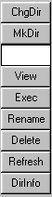
- Renaming files
•Just highlight the file you want to rename, and click on the Rename button!
- Deleting files
•Just highlight the file you want to delete, and click on the Delete button!
- Refreshing the Directory Display
To refresh the current directory display for either the local or remote system, click the Refresh button. The directory and file list box display any recent changes to the current directory.
You can also use the Refresh button to de-select any selected directories or files.

Step 4 - Ending Your FTP Session
To disconnect from your Xoom web site, click on the Close or Exit buttons at the bottom of the screen. The next time you connect with WS_FTP, your session profile will be saved for you. Simply make sure you have the right profile, and choose connect.

Step 5 - Viewing your web page
To view the page you just uploaded, use the following URL in your web browser:
If you named your first web page file index.html then you only need to enter the URL as follows: http://www.women.or.kr/~went00/

Tips & Suggestions
1. Directly below the local and remote windows, you'll notice three buttons labeled ASCII, Binary, and Auto. For best results:
- Image files such as gif or jpeg should be uploaded in Binary mode.
- We recommend all html files be uploaded in ASCII mode.
- To avoid problems with selecting the correct file type, you may wish to leave the
"Auto" box checked at all times.

2. HTML Filenames are case sensitive.
- We recommend you upload your files in lowercase only.
- When you write your html files, be sure and refer to any image or other html files in lowercase also. Your HTML and actual filenames must match exactly, in order for your page to display correctly.

3. User ID and Passwords are case sensitive
If you signed up with xoom, and chose a log-in name of Joe, typing joe into the MemberName when you publish would not work. The same holds true for passwords.

4. Connect - Startup Properties
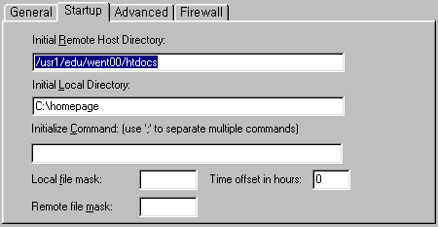
- Initial Remote Host Directory. Enter the initial remote start directory for interactive sessions. Such as: /usr1/edu/went00/htdocs
- Initial Local Directory. Enter the initial local start directory for interactive sessions.
Such as C:\homepage

