Publishing

You’ve been creating and testing your web pages on your local computer with your own browser. So now, you are finally ready to publish your site, to put it all online so that other people on the web can see it and link their pages to your site.

Contents

- Questions to ask your system administrator
- Having a default index file and correct filenames
- Moving files between systems
- Using FTP
- Hand on: Uploading your page using WS_FTP
- Troubleshooting

Questions to ask your system administrator

Before you can put your web site on the web, you’ll need to know the following:

- What’s the name of my server? For example www.women.or.kr, or just an IP number e.g., 192.123.45.67.
- Where on the server will I put my files? Usually, you have to create a special directory in your home directory and store your files there. You should know the name of this directory, e.g., public_html, www_html, htdocs etc.
- What is the URL of my top-level directory? This URL may be different from the actual pathname to your files. If your server has been set up so that you can use your home directory to store web pages, you can use the UNIX convention of the tilde (~) to refer to the web pages in your home directory, you don’t have to include the name of the directory you created in the URL itself. For example, if you have the web page my.html in a directory called public_html in my home directory (wenta), the URL would be http://www.myserver.com/~wenta/my.html
- What is the name of the system’s default index file? This file is located by default when a URL ends with a directory name. Usually, it is index.html but may sometimes be other names.
- Can I run CGI or other types of scripts?
- Do you provided any canned scripts that I can use for my web pages? Many ISPs provide ‘off-the-shelf’ scripts that allow you to put page counters or BBS (bulletin boards) on your web site.

Having a default index file and correct filenames

As you know, web servers usually have a default index file name that is loaded when a URL ends with a directory name instead of a filename. So you should know what the name of this default file is. Your home page and top-level index for each directory should be called by this name. If you use this default filename, the URL to that page will be shorter because you don’t have to include the actual file name.

Each file should also have an appropriate extension indicating what kind of file it is, so that the server can map it to the appropriate file type.

Format | Extension
HTML | .html, .htm
ASCII text | .txt
Postscript | .ps
GIF | .gif
JPG | .jpg, .jpeg
AU Audio | .au
WAV Audio | .wav
MPEG Audio | .mp2
MPEG Video | .mpeg, .mpg
QuickTime Video | .mov
AVI Video | .avi

If you are using special media in your web site that is not part of this list, you might need to special configure your server to handle this file type.

Moving files between systems

Usually you’ll have to move your web files from your local system to theirs using FTP. In particular, be careful to do the following:

- Transfer all files as binary.
- Watch out for filename restrictions. If your server is a PC, and you’ve been writing your files on some other system, you may have to rename your files and the links to them to have the right file-naming conventions. And also make sure that your filenames do not have spaces or other funny characters in them.
- Watch out for upper/lower case sensitivity.

Using FTP

What is File Transfer Protocol?
File Transfer Protocol (FTP) has been used almost exclusively on UNIX workstations and mainframes for many years to transfer files between remote computer systems. Early FTP software used a command-line interface difficult for some beginners to work with. As the Internet grew in popularity, new standards appeared (Gopher, WWW) providing more user-friendly interfaces. However, FTP remains the popular choice among computer professionals.

Hands-on: Uploading your page using WS_FTP

In this exercise, we will put your files on the WEB using WS_FTP.

What is WS_FTP?
WS_FTP is a Windows-based File Transfer Protocol (FTP) client that allows users to utilize the capabilities of FTP without having to know all the details of the protocol itself. WS_FTP simplifies FTP by offering a user-friendly Windows interface instead of a cumbersome command-line utility. CuteFTP gives novice PC users the ability to upload, download and edit files on remote FTP servers around the world.

Installation
If you haven't already done so, please download WS_FTPLE and install it on your computer. You can download WS_FTP from the Tucows (http://www.tucows.com).

This is a compressed file, so you will need a decompression utility to unzip this file. If you do not have one, please visit the Tucows (http://www.tucows.com) and download one now.

System Requirements
- Any PC running Windows 95, 98, 2000 or Windows NT 4.0 or later.
- At least 16 MB of free memory, 1 MB of free hard disk space, a connection to the Internet.

WS-FTP LE
- Version Number: 5.08
- Byte Size: 690.5 KB
- License: Freeware

Downloading
- Go to www.tucows.com and click on the download section (under the Windows 95 98/Network Tools/FTP and Archie)
- Select the link under the WS_FTP download section, then select ‘Download Now’.
- ‘Download Confirmed’ should appear.
- A screen will pop up asking where to save the file. Save it to your local drive.

When the download is complete, just double click on the .exe file to execute the installation.

Installing
Double-click the setup.exe icon. Follow the on-screen instructions.

Questions

Q: What’s the name of my server?
A: www.women.or.kr

Q: Where on the server will I put my files?
A: The name of directory is “htdocs”.
So you have to create a “htdocs” in your home directory and store all your files there.

Q: What is the URL of my top-level directory?
A: If your ID is “went00” ,
then the URL would be http://www.women.or.kr/~went00

Q: What is the name of the system’s default index file?
A: It is index.html

Open WS_FTPLe and create a Session Profile

Once you open WS_FTPLE, the first screen you will see is the Session Profile screen, which will look similar to this:
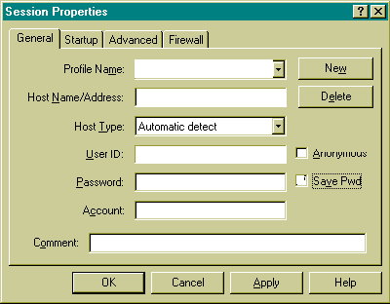
- You'll need to enter the following settings after click on the [New] button in your Session Profile:
- Profile Name: Went2000 web Site (you get your choice on this one)
- Host Name: women.or.kr
- Host Type: Automatic detect (default)
- User ID: Insert your ID (such as went00)
- Password: Insert your password

Make sure that user ID and password are case sensitive.

- If you wish, you may choose to save your password so that you don't have to enter it each time you log in with WS_FTPLE. If you wish to enable this time-saving feature, check the box marked [Save Pwd] like this:

- Be sure the Anonymous box is unchecked. Do NOT enter any other information beyond this. There is no need to enter a directory name; the above settings will automatically place you in your base directory.
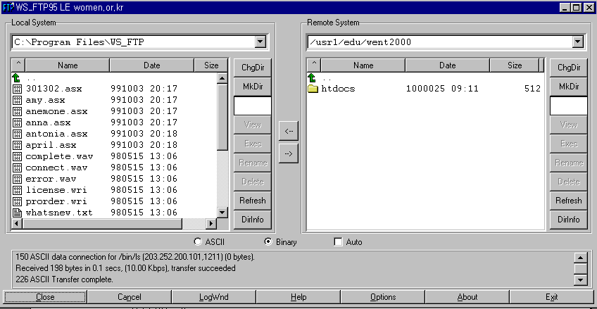
4. When you are finished entering these settings, click on the [OK] button, and you will be connected to your web server.

WS_FTPLE Main Screen
Now that you are logged into your web site, the WS_FTPLE screen should look similar to this:

The main screen is used to transfer files to and from remote servers and is divided into five panes:

- UPPER LEFT WINDOW (Local path). The local path displays the path which is selected directory from your local system.
- CENTER LEFT WINDOW (Local directory). The local window displays the files and directories of selected directory from your hard drive.
- UPPER RIGHT WINDOW (Remote path). The remote path displays the path which is selected directory from your server.
- CENTER RIGHT WINDOW (Remote directory). The remote window displays the files and directories of the server you are connected to.
- LOWER WINDOW (Log status). The log window displays the commands you send and the server’s responses. WS_FTP logs this information to inform you of completed transactions or assist in troubleshooting.

Creating the Directory
In this server, you have to create a “htdocs” in your home directory before put your files on the web server, then upload all your files into “htdocs”.
To create the new directory, do the following:

- To create a directory, click the “Mkdir” button on the remote side.
- Enter a name for directory (htdocs)
Transferring Files Back and Forth

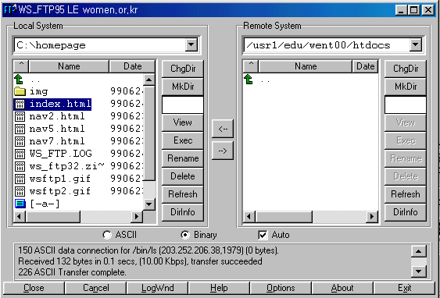

As shown above, the left-hand window displays the directories and files on your local hard drive, and the right hand window displays the directories and files on your web site. To transfer files from one window to the other, simply click once on the file you wish to transfer, then click once on the arrow between the two windows, which points in the direction that you wish to transfer the file to.

To Upload files
To upload a file from your computer to ours, select the file you want to upload by clicking on it once. This will highlight it (as index.html is highlighted above). Then, select the method of transfer: and then click on the “-->“ button to upload the file.

• ASCII -- for HTML files, and text files (.html, .txt, etc.)
• Binary -- for graphic files, movies (.jpg, .gif, etc.)
• Auto -- depending on the extension, WS_FTP will upload the file the correct way. Check the online help files with WS_FTP to get this working correctly. By default, it only transfers .TXT files as ASCII -- everything else it sends as Binary…

To Download files
To download a file from your computer to ours, select the file you want to download, by clicking on it once in the right-hand window. Then, select the method of transfer:
And then click on the “ <-- '' button to download the file

Modifying files
Just upload your modified file and it will overwrite any files previously on the server with the same name.

Additional Features

WS_FTPLE also allows you to create new directories, delete directories, as well as delete and rename files. These features are available by choosing the buttons to the right of the Remote System window.

Renaming files
Just highlight the file you want to rename, and click on the Rename button!

Deleting files
Just highlight the file you want to delete, and click on the Delete button!

Refreshing the Directory Display
To refresh the current directory display for either the local or remote system, click the Refresh button. The directory and file list box display any recent changes to the current directory.
You can also use the Refresh button to de-select any selected directories or files.

Ending Your FTP Session
To disconnect from your web site, click on the Close or Exit buttons at the bottom of the screen.

Connecting to an Existing Site
The next time you connect with WS_FTP, your session profile will be saved for you. Simply make sure you have the right profile, and click the Connect button and WS_FTP connects to the site.

Viewing your web page
To view the page you just uploaded, use the following URL in your web browser:
If you named your first web page file index.html then you only need to enter the URL as follows: http://www.women.or.kr/~went00/

Tips & Suggestions

- Directly below the local and remote windows, you'll notice three buttons labeled ASCII, Binary, and Auto. For best results:
- Image files such as gif or jpeg should be uploaded in Binary mode.
- We recommend all html files be uploaded in ASCII mode.
- To avoid problems with selecting the correct file type, you may wish to leave the "Auto" box checked at all times.

- HTML Filenames are case sensitive.
- We recommend you upload your files in lowercase only.
- When you write your html files, be sure and refer to any image or other html files in lowercase also. Your HTML and actual filenames must match exactly, in order for your page to display correctly.

- User ID and Passwords are case sensitive
If you signed up with web server, and chose a log-in name of Joe, typing joe into the MemberName when you publish would not work. The same holds true for passwords.

4. Connect - Startup Properties
- Initial Remote Host Directory. Enter the initial remote start directory for interactive sessions. Such as: /usr1/edu/went00/htdocs
- Initial Local Directory. Enter the initial local start directory for interactive sessions, e.g., C:\homepage

Troubleshooting

What you happens if you upload all your files to the server, try to bring up your home page in your browser, and something goes wrong?

Can’t access the server
If your browser can’t access your server, this problem is most likely not one that you can fix. You should check the following:
- You have the right server name and that it’s a complete host name.
- You haven’t mistyped your URL and that you are using the right protocol. If your webmaster told you that your URL included a port number, you must including that port number in the URL after the host name.
- Check your network connection is working. Can you get to other web servers? Can you get to the top-level home page for the site itself?
If none these ideas solve the problem, it may because your server is down or not responding. You’ll have to contact your system administrator.

Can’t access files
What if all files are showing up as NOT Found or Forbidden?
- Check your URL. If you are using a URL with a directory name at the end, try using an actual file name at the end and see whether this trick works.
- Check the path to your files. Remember that the path in the URL may be different from the path on the actual disk.
- Uppercase and lowercase are significant. If your file is MyFile.html, make sure you’re not trying myfile.html or Myfile.html.
- Check the file permissions. If the URL appears to be correct, the next thing to check is file permissions. On UNIX systems, all your directories should be executable, and all your files should be readable. You can make sure all the permissions are correct by using these commands:
chmod 755 filename
chmod 755 directoryname

Can’t access images
You can get your HTML files just fine, but your images are coming up as icons or broken icons. Check:
- If the references to your images are correct. If you’ve used relative pathnames, you should not have this problem. If you’ve used full pathnames or file URLs, the references to your images may very well have broken when you moved the files to the server.
- If you transferred all images in binary mode. The images worked just fine on your local system, the only other place a problem could have occurred is in transferring the files from one system to another. Make sure you transfer all your image data in binary mode.
- If you are using the right tag.
- On the case sensitivity in your image filenames, and also check the correct file extensions.

Links don’t work
If your links don’t work:
- Check the references to your files are correct. If you’ve used relative pathnames, you should not have this problem
- Check the case sensitivity in your files.
- Check you are using the correct tag.

File are displaying wrong
Say you’ve got an HTML file or a file in some media format that displays or links just fine on your local system. After you upload the file to the server and try to view it, the browser gives you gobbledygook. For example, it displays the HTML code itself instead of the HTML file, or it tries to display an image or media file as text.
- Check you are using the correct file extensions, and also correct uppercase and lowercase filenames.
- Your server is misconfigured to handle your files. For example, if all your HTML files have extensions of .htm, your server may not understand that .htm is an HTML file; or you might be using a new form of media that your server doesn’t understand.
To fix this problem, you’ll have to configure your server to handle the file extensions for the media you’re working with. If you’re working with someone else’s server, you’ll have to contact your system administrator. .

