Publishing

When your web pages are ready to go on the World Wide Web, you are ready to “publish” them, to make them accessible to the public. Before you do it, however, bear in mind that when you publish information on the World Wide Web, you are electronically publishing the material. Standard copyright laws do apply on the Web and it is wise to avoid publishing the work (text, image, audio, video) of others without their formal permission.

There are different types of materials that can be published on the World Wide Web, the most common being:

- Plain text, e.g. txt
- Hypertext, e.g. html
- Multimedia
- Graphics, e.g. jpg/jpeg, gif
- Audio, e.g. wav, au, mp3.
- Video (.mpg or .mov)
- Animation, i.e. Flash, Shockwave

- Scripts (.cgi), Java applets (.class, .js) or other Web program files (.asp, .cfm)
- Files in proprietary formats, such as Adobe Acrobat (.pdf) and Word (.doc)
- Downloadable files (.exe, .hqx)

Web publishing consists of creating or editing a file and storing it on a computer configured with special software; this computer is referred to as the “web server”. There are basically four steps in web publishing:

- Create a web page.
- See the web page on a web-browser (offline).
- Transfer the web page to the web server.
- Test the web page online.

Web-builder David J. Emberton from Emberton.com divides web publishing into two types:
- Information publishing
- Creative publishing

Information Publishing

Information publishing incorporates any kind of computerized content creation, such as drawing data from a database or processing usage statistics and viewer feedback. Information publishers have the advantage of automation. After the initial technical investment of programming and implementing the system, Web sites driven by data are largely a hands-off affair, and you can tackle updates (if you're lucky) through user-friendly back office systems.”

Creative Publishing

“Creative publishers have it a little tougher. If you're a writer, photographer, videographer, or artist, you're probably not enjoying much automation in the publishing process. Creative developers face a double dilemma because they not only have to input their ideas into the computer, but they also have to transport the resulting files to the Web server. For many, the technical process absorbs so much time that they are exhausted by the mere thought of updating their Web site. Until recently, transferring words, pictures, and sounds from your imagination to the Web was a task mired in complexity and repetition. Luckily, creative publishers now have a few simpler alternatives.”

Publishing Tools

You will need an FTP client/program to publish your web pages to the World Wide Web.

FTP - File Transfer Protocol

FTP is the common procedure used for downloading and uploading files over the Internet. With FTP you can login to another Internet site and transfer (meaning, send or receive) files. Some sites have public file archives that you can access by using FTP with the account name "anonymous" and your e-mail address as the password. This type of access is called anonymous FTP. Macintosh owners use a program called Fetch; one of the best FTP programs for Windows is called WS-FTP.
(Source: www.netlingo.com)

Downloading/Uploading

When you are transferring files from a remote computer to your computer (this way), you are downloading. On the other hand, when you are transferring files from your computer to a remote computer (that way), you are uploading.

Web-based FTP

The desktop FTP client is installed in your desktop computer whereas the web-based FTP client is installed in the web server. A web-based FTP site allows you to download and upload files between your computer and the host server of the site without you having to install an FTP client on your computer.

Examples of web-based FTP sites:
TUCOWS Software Download Site >> http://www.tucows.com
Zdnet Software Download Site >> http://www.zdnet.com

Using FTP – Hands-on: Uploading your page using WS_FTP

In this exercise, we will put your files on the Web using WS_FTP.

What is WS_FTP?

WS_FTP is a Windows-based File Transfer Protocol (FTP) client that allows users to utilize the capabilities of FTP without having to know all the details of the protocol itself. WS_FTP simplifies FTP by offering a user-friendly Windows interface instead of a cumbersome command-line utility. CuteFTP gives novice PC users the ability to upload, download and edit files on remote FTP servers around the world.

Installation

If you haven't already done so, please download WS_FTPLE and install it on your computer. You can download WS_FTP from the Tucows (http://www.tucows.com).

This is a compressed file, so you will need a decompression utility to unzip this file. If you do not have one, please visit the Tucows (http://www.tucows.com) and download one now.

System Requirements
- Any PC running Windows 95, 98, 2000 or Windows NT 4.0 or later.
- At least 16 MB of free memory, 1 MB of free hard disk space, a connection to the Internet.

WS-FTP LE
- Version Number: 5.08
- Byte Size: 690.5 KB
- License: Freeware

Downloading
- Go to www.tucows.com and click on the download section (under the Windows 95 98/Network Tools/FTP and Archie)
- Select the link under the WS_FTP download section, then select ‘Download Now’.
- ‘Download Confirmed’ should appear.
- A screen will pop up asking where to save the file. Save it to your local drive.

When the download is complete, just double click on the .exe file to execute the installation.

Installing

Double-click the setup.exe icon. Follow the on-screen instructions.

Questions

Q: What’s the name of my server?
A: www.women.or.kr

Q: Where on the server will I put my files?
A: The name of directory is “htdocs”.
So you have to create a “htdocs” in your home directory and store all your files there.

Q: What is the URL of my top-level directory?
A: If your ID is “went00” ,
then the URL would be http://www.women.or.kr/~went00

Q: What is the name of the system’s default index file?
A: It is index.html

Open WS_FTPLe and create a Session Profile

Once you open WS_FTPLE, the first screen you will see is the Session Profile screen, which will look similar to this:
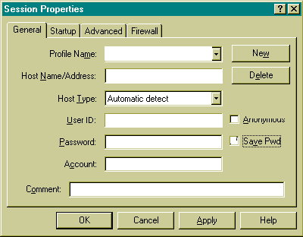
- You'll need to enter the following settings after click on the [New] button in your Session Profile:
- Profile Name: Went2000 web Site (you get your choice on this one)
- Host Name: women.or.kr
- Host Type: Automatic detect (default)
- User ID: Insert your ID (such as went00)
- Password: Insert your password

Make sure that user ID and password are case sensitive.

- If you wish, you may choose to save your password so that you don't have to enter it each time you log in with WS_FTPLE. If you wish to enable this time-saving feature, check the box marked [Save Pwd] like this:

- Be sure the Anonymous box is unchecked. Do NOT enter any other information beyond this. There is no need to enter a directory name; the above settings will automatically place you in your base directory.
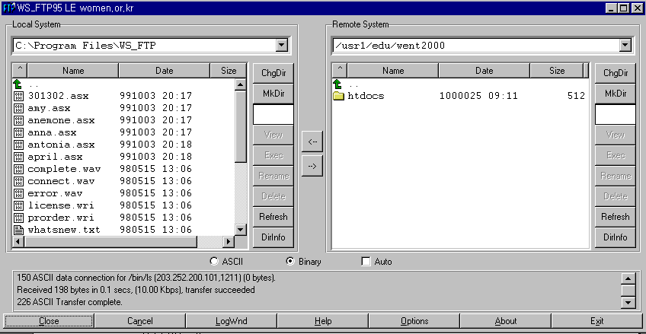
4. When you are finished entering these settings, click on the [OK] button, and you will be connected to your web server.

WS_FTPLE Main Screen
Now that you are logged into your web site, the WS_FTPLE screen should look similar to this:

The main screen is used to transfer files to and from remote servers and is divided into five panes:

- UPPER LEFT WINDOW (Local path). The local path displays the path which is selected directory from your local system.
- CENTER LEFT WINDOW (Local directory). The local window displays the files and directories of selected directory from your hard drive.
- UPPER RIGHT WINDOW (Remote path). The remote path displays the path which is selected directory from your server.
- CENTER RIGHT WINDOW (Remote directory). The remote window displays the files and directories of the server you are connected to.
- LOWER WINDOW (Log status). The log window displays the commands you send and the server’s responses. WS_FTP logs this information to inform you of completed transactions or assist in troubleshooting.

Creating the Directory

In this server, you have to create a “htdocs” in your home directory before put your files on the web server, then upload all your files into “htdocs”.
To create the new directory, do the following:

- To create a directory, click the “Mkdir” button on the remote side.
- Enter a name for directory (htdocs)

Transferring Files Back and Forth

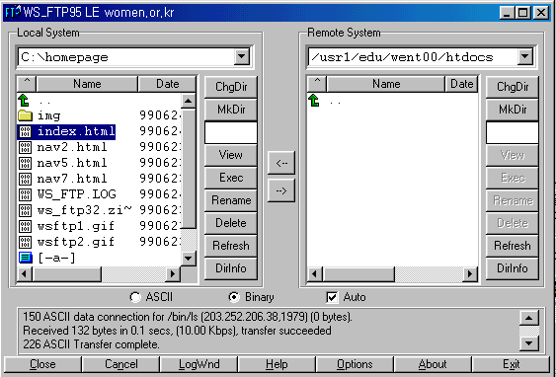

As shown above, the left-hand window displays the directories and files on your local hard drive, and the right hand window displays the directories and files on your web site. To transfer files from one window to the other, simply click once on the file you wish to transfer, then click once on the arrow between the two windows, which points in the direction that you wish to transfer the file to.

To Upload files

To upload a file from your computer to ours, select the file you want to upload by clicking on it once. This will highlight it (as index.html is highlighted above). Then, select the method of transfer: and then click on the “-->“ button to upload the file.

- ASCII -- for HTML files, and text files (.html, .txt, etc.)
- Binary -- for graphic files, movies (.jpg, .gif, etc.)
- Auto -- depending on the extension, WS_FTP will upload the file the correct way. Check the online help files with WS_FTP to get this working correctly. By default, it only transfers .TXT files as ASCII -- everything else it sends as Binary…
\

To Download files

To download a file from your computer to ours, select the file you want to download, by clicking on it once in the right-hand window. Then, select the method of transfer:
And then click on the “ <-- '' button to download the file

Modifying files

Just upload your modified file and it will overwrite any files previously on the server with the same name.

Additional Features

WS_FTPLE also allows you to create new directories, delete directories, as well as delete and rename files. These features are available by choosing the buttons to the right of the Remote System window.

Renaming files

Just highlight the file you want to rename, and click on the Rename button!

Deleting files

Just highlight the file you want to delete, and click on the Delete button!

Refreshing the Directory Display

To refresh the current directory display for either the local or remote system, click the Refresh button. The directory and file list box display any recent changes to the current directory.
You can also use the Refresh button to de-select any selected directories or files.

Ending Your FTP Session

To disconnect from your web site, click on the Close or Exit buttons at the bottom of the screen.

Connecting to an Existing Site

The next time you connect with WS_FTP, your session profile will be saved for you. Simply make sure you have the right profile, and click the Connect button and WS_FTP connects to the site.

Viewing your web page

To view the page you just uploaded, use the following URL in your web browser:
If you named your first web page file index.html then you only need to enter the URL as follows: http://www.women.or.kr/~went00/

Tips & Suggestions

- Directly below the local and remote windows, you'll notice three buttons labeled ASCII, Binary, and Auto. For best results:
- Image files such as gif or jpeg should be uploaded in Binary mode.
- We recommend all html files be uploaded in ASCII mode.
- To avoid problems with selecting the correct file type, you may wish to leave the "Auto" box checked at all times.

- HTML Filenames are case sensitive.
- We recommend you upload your files in lowercase only.
- When you write your html files, be sure and refer to any image or other html files in lowercase also. Your HTML and actual filenames must match exactly, in order for your page to display correctly.

- User ID and Passwords are case sensitive
If you signed up with web server, and chose a log-in name of Joe, typing joe into the MemberName when you publish would not work. The same holds true for passwords.

- Connect - Startup Properties
- Initial Remote Host Directory. Enter the initial remote start directory for interactive sessions. Such as: /usr1/edu/went00/htdocs
- Initial Local Directory. Enter the initial local start directory for interactive sessions, e.g., C:\homepage

Troubleshooting

What you happens if you upload all your files to the server, try to bring up your home page in your browser, and something goes wrong?

Can’t access the server

If your browser can’t access your server, this problem is most likely not one that you can fix. You should check the following:

- You have the right server name and that it’s a complete host name.
- You haven’t mistyped your URL and that you are using the right protocol. If your webmaster told you that your URL included a port number, you must including that port number in the URL after the host name.
- Check your network connection is working. Can you get to other web servers? Can you get to the top-level home page for the site itself?

If none these ideas solve the problem, it may because your server is down or not responding. You’ll have to contact your system administrator.

Can’t access files

What if all files are showing up as NOT Found or Forbidden?

- Check your URL. If you are using a URL with a directory name at the end, try using an actual file name at the end and see whether this trick works.
- Check the path to your files. Remember that the path in the URL may be different from the path on the actual disk.
- Uppercase and lowercase are significant. If your file is MyFile.html, make sure you’re not trying myfile.html or Myfile.html.
- Check the file permissions. If the URL appears to be correct, the next thing to check is file permissions. On UNIX systems, all your directories should be executable, and all your files should be readable. You can make sure all the permissions are correct by using these commands:
chmod 755 filename
chmod 755 directoryname

Can’t access images

You can get your HTML files just fine, but your images are coming up as icons or broken icons.

Check:
- If the references to your images are correct. If you’ve used relative pathnames, you should not have this problem. If you’ve used full pathnames or file URLs, the references to your images may very well have broken when you moved the files to the server.
- If you transferred all images in binary mode. The images worked just fine on your local system, the only other place a problem could have occurred is in transferring the files from one system to another. Make sure you transfer all your image data in binary mode.
- If you are using the right tag.
- On the case sensitivity in your image filenames, and also check the correct file extensions.

Links don’t work

If your links don’t work:

- Check the references to your files are correct. If you’ve used relative pathnames, you should not have this problem
- Check the case sensitivity in your files.
- Check you are using the correct tag.

File are displaying wrong

Say you’ve got an HTML file or a file in some media format that displays or links just fine on your local system. After you upload the file to the server and try to view it, the browser gives you gobbledygook. For example, it displays the HTML code itself instead of the HTML file, or it tries to display an image or media file as text.

- Check you are using the correct file extensions, and also correct uppercase and lowercase filenames.
- Your server is misconfigured to handle your files. For example, if all your HTML files have extensions of .htm, your server may not understand that .htm is an HTML file; or you might be using a new form of media that your server doesn’t understand.
To fix this problem, you’ll have to configure your server to handle the file extensions for the media you’re working with. If you’re working with someone else’s server, you’ll have to contact your system administrator. .

References

The University of Oregon >> http://www.uoregon.edu/
Webopedia >> http://www.webopedia.com
WENT2000 – Track 1

