Suupplementary Reading

(taken from WENT99 Training Kit)

Using Advanced Search Features

Task 1 Developing a Search Strategy 1

Task 2 Performing Search 3

Task 3 Searching for Phrases 4

Task 4 Searching for Plurals 5

Task 5 Searching in Fields 6

Task 6 Refining your Search 8

Task 7 Restricting Search by Language 9

Task 8 Structuring Long Or Complex Searches 10

Task 9 Restricting Search by Dates 11

Appendix 1 12

Objectives
When you have completed these exercises you should be able to:

- Devise a strategy for web searching and follow a procedure for planning a search.

- Make effective use of web search engine features and functions

Task 1: Developing a Search Strategy
Objective: To devise a search strategy and plan a search in advance

Activity 1.1 In this task you are going to develop a search strategy on a sample topic area.
Planning a search strategy before you actually start to search on the web can be a good idea as it helps you to focus more precisely on your topic and your information needs. You can then apply this approach to a topic of your own choice.
The sample topic you are going to develop a search strategy for is as follows:
Women Asia Internet

First of all, use the space below to make a list of as many words as you can think of which might be associated with this topic. You might want to think about things like plural and singular versions of words, similar concepts, narrower and broader terms, and synonyms.

....................................................................................................................................................................................................................................................................................................................................................................................................................................................................................................................................................................................................................................................................................................................................................................................................................................................................................................................................................................................

Activity 1.2 Take a look at Appendix 1 of this document for a list of possible words and topics which might be relevant to the above subject.
You will notice that this list of words has been grouped into concepts. Using the space below, group your own list of words into concept areas, as has been done in Appendix 1.
....................................................................................................................................................................................................................................................................................................................................................................................................................................................................................................................................................................................................................................................................................................................................................................................................................................................................................................................................................................................

Activity 1.3 You are now going to structure your search terms using AND, OR, NOT (boolean operators), phrases and truncation.
You can use some or all of your words from the list you have generated.
Using the space below, structure your search using some or all of the key words you have chosen.
.............................................................................................................................................................................................................................................................................................................................................................................................................................................

Activity 1.4 At this point you should also think about any other factors that you might want to consider in your search.
For example, do you want to limit the search to documents from the English language? Do you want to limit your search to documents over a particular date span?
Make a note in the space provided below of any other factors you might want to take into
consideration when searching for information on this topic.

............................................................................................................................................................................................................................................................................................................................ ............................................................................................................................................................................................................................................................................................................................

Task 2: Performing Search
Objective: To use the Alta Vista search engine to perform a search

Activity 2.1 In your WWW browser enter the URL:
http://www.altavista.digital.com
Activity 2.2 Type the words women Asia Internet into the text entry box and click on the Search button to perform your search. Alta Vista will perform your search and display the results on screen.
Make a note of how many results you retrieve from the search in the space provided below:

........................................................................................................................................
........................................................................................................................................
........................................................................................................................................

Activity 2.3 Now perform the search again. This time type +women +Asia +Internet in the text entry box (ie: place a plus sign in front of each of your terms).
Click on the Search button to start your search.
Make a note of how many results you retrieve from the search in the space provided below:

........................................................................................................................................
........................................................................................................................................
........................................................................................................................................

Take a look at your search results. You should notice a difference in both the number and content of documents you retrieve from this second search. You should have found fewer documents than in the previous search, and overall, more of these documents should be relevant to your query.
This is because the query women Asia Internet will find pages where either word is present, not necessarily both of them. This is the equivalent of using Boolean OR in a search.

The search on +women +Asia +Internet will find pages where all three words are present. This is the equivalent of using Boolean AND in a search to link terms together.

Activity 2.4 Try some more searches on Alta Vista using the plus sign. Try some of the combinations of words which you listed in Task 1. You can also try your own topic areas of interest if you prefer.

Task 3: Searching for Phrases
Objective: To explore searching for phrases on Alta Vista.

Activity 3.1 Perform a search on Alta Vista for the following topic:
+human rights +women
Click on the Search button to perform your search, and take a look at your results.
Make a note in the space provided below of how many results you retrieve.

........................................................................................................................................
........................................................................................................................................
........................................................................................................................................
Activity 3.2 Now perform this search again. This time, type the following:
+”human rights” +women

Note the quotation marks around the phrase “human rights”.

Take a look at your results and make a note of how many results you have retrieved. Compare this with the number of results from your first search above.

........................................................................................................................................
........................................................................................................................................
........................................................................................................................................

You should find that your results from the second search are more likely to be relevant to the topic than those from the first search. You should also find that you have retrieved fewer results from the second search.

The quotation marks enable you to search for a particular phrase; that is, where two or more words appear exactly adjacent to each other in the text of a document.

Activity 3.3 Try some more searches on Alta Vista using phrase searching features. Try some more combinations of words and phrases from the list of terms which you drew up in Task 1. You can also try your own topic areas of interest if you prefer.

Task 4: Searching for Plurals
Objective: To explore methods of searching for plural instances of words and phrases on Alta Vista.

Activity 4.1 Perform a search on Alta Vista for the following topic:
+Asia +women +networking
Click on the Search button to perform your search, and take a look at your results.
Make a note in the space provided below of how many results you retrieve.

........................................................................................................................................
........................................................................................................................................
........................................................................................................................................

Activity 4.2 Now perform this search again. This time, type the following:
+Asia +women +network*

Note the asterisk at the end of the word network.
Take a look at your results and make a note of how many results you have retrieved. Compare this with the number of results from your first search above.

........................................................................................................................................
........................................................................................................................................
........................................................................................................................................

You should find that you retrieve more results from the second search than you did from the first search. The asterisk acts as a truncation character; finding all the words which have network as their main stem. This means that it will find documents containing the words network and networks.

Task 5 Searching in Fields
Objective: To explore methods of searching in different fields of documents

Activity 5.1 Perform a search on Alta Vista for the following topic:
“Beijing Platform for Action”
Click on the Search button to perform your search, and take a look at your results.
Make a note in the space provided below of how many results you retrieve.

......................................................................................................................................
......................................................................................................................................
......................................................................................................................................

Activity 5.2 Now perform this search again. This time, type the following:
title:” Beijing Platform for Action”

Take a look at your results and make a note of how many results you have retrieved. Compare this with the number of results from your first search above.

........................................................................................................................................
........................................................................................................................................
........................................................................................................................................

You should find that you retrieve fewer results from the second search than you do from the first search. The documents you retrieve should also be generally more relevant.
In the second search, Alta Vista is searching only the titles of documents for your keywords.
It is likely that a document which contains the words “Beijing Platform for Action” in its title is more likely to be relevant to your needs than one which just briefly mentions these words somewhere in the main body of the document.
You also stand a better chance of finding the home page for the Beijing Platform for Action by searching titles: otherwise you might simply find documents which mentioned the Beijing Platform for Action.
Activity 5.3 There are other fields which you can also search in Alta Vista to improve your search results. A list of these is given below:
text: enables you to restrict a search just to the main body of a document.
link: restricts the search to hypertext links in documents. Useful if you want to find out how many sites link to a particular web page
anchor: searches for the visible part of a hypertext link (ie: the actual words you click on rather than the underlying URL)
url: searches for a particular URL (or part of a URL) on a web page, whether as a hypertext link or not.
host: searches on the host name -ie: host: jcanet. Useful if you can’t remember the full URL of a web page
domain: searches on the domain name (country code such as .kr or other domains such as org, edu, ac, net etc. Useful for restricting your search to particular types of documents - eg: non-profit organization sites, Korea only web sites etc.)
image: searches on images on web pages (actually using the filename of the image, or the alternative text which some web authors provide.
applet: searches for applets, which are small programs embedded into web documents.

Try some more searches using some of the different fields shown above. Try these on the list of words you drew up in Task 1, or on your own subject area of interest. For example, you could search for pictures from art books by typing:
image:art
or
+image:art +Asia

Task 6: Refining Your Search
Objective: To explore methods of refining search on Alta Vista

Activity 6.1 Perform a search on Alta Vista for the following topic:
+women +Asian
Click on the Search button to perform your search, and take a look at your results.
Make a note in the space provided below of how many results you retrieve.

........................................................................................................................................
........................................................................................................................................
........................................................................................................................................

Activity 6.2 Click on the Refine button. This will enable you to refine your search down to particular areas of vegetarian cookery. Alta Vista will look at all the documents it found for your first search, and sort them into different categories according to the different sorts of topics which they cover.

Examine the range of different topics that were returned by your search? If any of these topic areas are of specific interest to you, you can then refine your search in order to look at those documents in particular.

You can now see at a glance the sorts of topics that the documents retrieved are covering. If any of these topics are of particular interest to you, you can now choose the Require option to prioritise them in your search (shown above). Select the Require option from the pull-down menus next to each category. Click on the Search button to run your search again with the refinement options selected.

Note: it is generally best to choose one category at a time, and then run the search again. Review your results before refining the search again.

Task 7: Restricting your Search by Language
Objective: To explore methods of restricting a search by language

Activity 7.1 Perform a search on Alta Vista for the following topic:
+women +Internet +Asia
Click on the pull down menu item shown below, and choose Japanese from the list of languages available for searching.
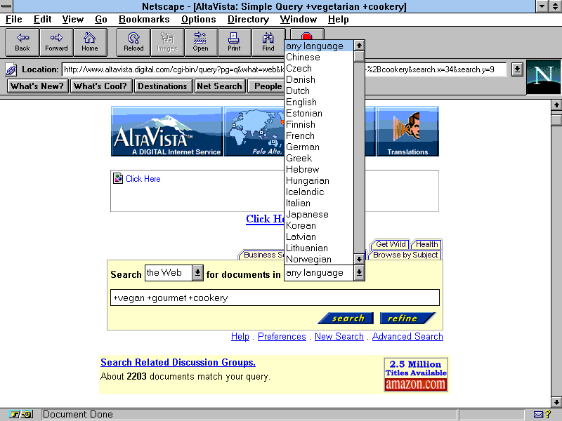
Figure 7 Searching By Language
Your search will now be restricted to documents which are in the Japanese language.

Task 8: Structuring Long or Complex Searches
Objective: To structure a long, complex search using the Advanced Search option.

Activity 8.1 Click on the Advanced Search option on the Alta Vista home page. You can use the Advanced Search option to structure longer queries more effectively.
Perform a search on the following topic:
(Internet or networking) and (network* or organization*) and ("human rights”)

Type the search exactly as shown above.
Notice the use of parentheses to group together certain catergories of words:
(Internet or networking)

the use of truncation:
network* organization*

and the use of boolean AND and OR:
Internet or networking
instead of the plus sign.

The advanced search option is the best place to perform a search on much longer queries, like the one shown above, where you want to include lots of different terms.

Activity 8.2 Try performing another search on Alta Vista using the Advanced Search option. You can choose a search from the list of words and search strategies you drew up in Task 1, or choose a topic of your own if you prefer.

Task 9: Restricting Your Search by Date
Objective: To restrict a search to a particular date period.

Activity 9.1 Use the Advanced Search option to perform a search on Alta Vista for the following topic:
Asia and women and (Beijing Platform for Action”)

In the date field (shown below) you should type the following:
From: 1/Jan/98
To: 1/June/99

This will restrict your search to documents which were made available on the web between that date period (or have been updated in that period). This can be useful for finding very up to date documents, or in order to screen out older material.

Appendix 1
Examples of structured searches using Boolean logic, parentheses and truncation.

women feminism activism

women movement society

women rights activism

women media communication

women media pornography

women democracy Asia

women rights democracy

